Amazon.com
The Amazon web-services provide machine accessibity to a range of functions supporting automated interactions with both buyers and sellers. Web-services are used to support cross-enterprise business process integration.

use-cases

Amazon web services for buyers
Creation of an associate web-site that provides access to Amazon products. Transactions passing through the site are tagged with the Associate ID, allowing the associate to earn referral fees.
Operations (atomic processes) support:
- Product and Catalogue data search
- Getting transaction information
- Purchasing (shopping cart)

Amazon web-services for sellers
A third-party bookshop can offer inventory for sale with Amazon (zShops), or participate in the Amazon Marketplace (matching buying offers).
Operations (atomic processes) support:
- Inventory management
- Retrieving order information
- Submitting refunds
- Logistics

Ontology
The Amazon Data model is one small step away from an ontology.

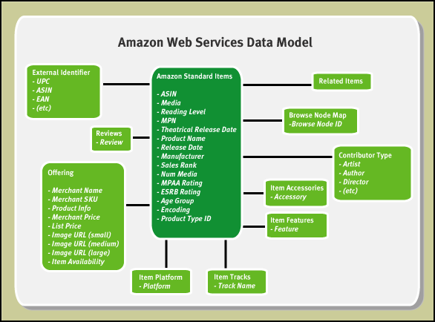

Semantic challenges
- Generation of an associate web-site from a declarative description of the service. Process model -> Site-Map?
- Description of complex choreographies such as the Marketplace.
- Matching of selling and buying offers.
- Complex XML data types in OWL-S data-flows (utilising domain ontology).
- Aggregation/orchestration of different suppliers.

